4.2 Double Integrals Worksheet

- In the xy-plane, the region R is bounded by , and the x-axis. Determine the volume of the solid bounded above by and below by the region R.
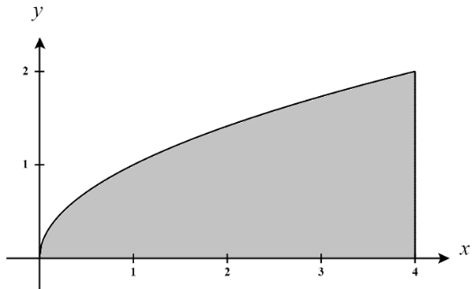
A picture of the region R is shown at the right. We see that the region R can be defined as OR

We know that the volume of the solid is given by
OR
We will calculate the first double integral as follows:
Let then . Our bounds become . Then,

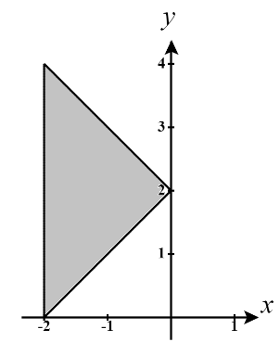
- In the xy-plane, the region R is bounded by the curves , and . Sketch the region and determine the volume of the solid bounded above by .

A picture of the region R is shown at the right. We see that the region R is most easily defined as

We know that the volume of the solid is given by .
We will calculate the double integral as follows:

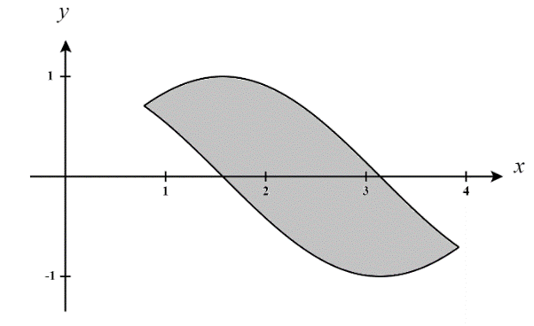
- Use a double integral to compute the area of the region bounded by the graphs of and between and .

A picture of the region R is shown at the right. We see that the region R is most easily defined as

We know that the volume of the solid is given by .
We will calculate the double integral as follows:

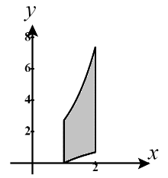
- Use a double integral to determine the area of the region D bounded by , on the interval .

A picture of the region D is shown at the right. We see that the region D can be most easily defined as .
We know that the area of the region is given by
We will calculate the first double integral as follows:
While the first integral here is easy, we will need to use integration by parts on the 2nd integral.
Let and then . Then,

- Evaluate where D is the region bounded by circle centered at the origin with radius 2.

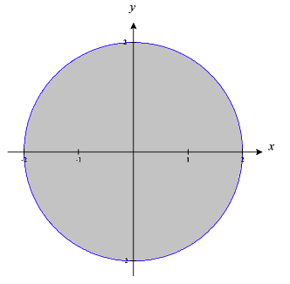
A picture of the region D is shown at the right. We see that D can be defined as
Therefore,
Let , then . The bounds become .
Therefore,

- Evaluate where D is the region bounded by and .
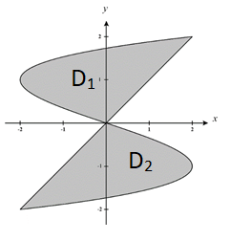
A picture of the region D is shown at the right. We see that the region D is difficult to define as a single type 1 or type 2 region. Therefore, we will split the region D up into two subregions and (upper and lower halves). We see that:
&
We will set up double integrals over and and their sum will be the total area we desire. We calculate:
- Sketch the region of integration and change the order of integration.
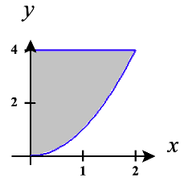
The bounds on the integral communicate the region .
A sketch of the region is shown at the right.
We then redefine this region as .
Therefore, .

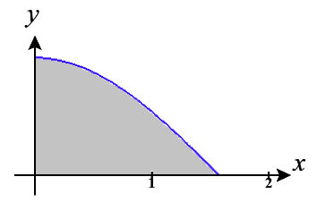
The bounds on the integral communicate the region .
A sketch of the region is shown at the right.
We then redefine this region as .
Therefore, .

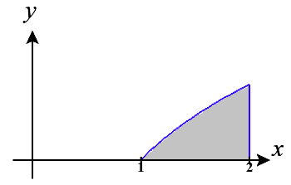
The bounds on the integral communicate the region .
A sketch of the region is shown at the right.
We then redefine this region as .
Therefore, .

- Evaluate the double integral .
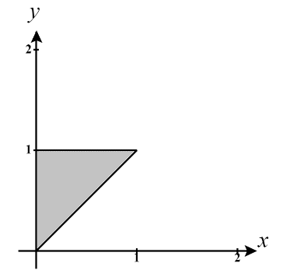
We see that integrating with respect to y first will be difficult here. So, we will plan to reverse the order of integration. First, we must identify the region we are integrating over. We see that and we picture this region at the right (Note that the equation of the slanted line is given by ). We re-express this region as:

Then,

- Evaluate the double integral .

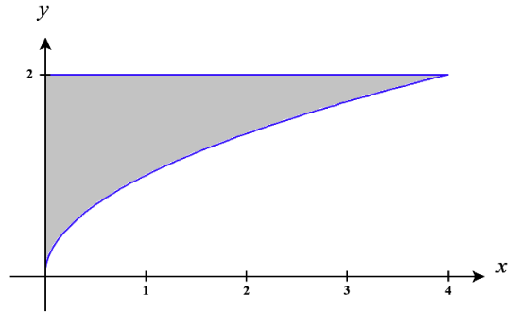
We see that integrating with respect to y first will be difficult here. So, we will plan to reverse the order of integration. First, we must identify the region we are integrating over. We see that and we picture this region at the right. We re-express this region as:

Then,
Let , then .
The bounds on the integral become .

Therefore, .

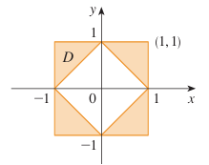
- Express D as a union of regions and evaluate the integral.

We note that .
We define each of these regions in the following ways.
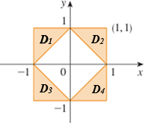

Therefore,

Note that we could use symmetry to help speed up this process. We have to be careful though. While are all symmetrical the volumes over these regions and under are NOT all symmetrical. We have to consider not only the symmetry of the regions , but the symmetry of the overall 3D regions that we are finding the volumes of. When we do this we can see that the volumes over are symmetrical and the volumes over are symmetrical. Therefore, we can say that
and shortcut the work here substantially.
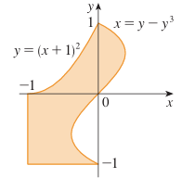

We break the region apart as shown in the image below. We then recognize that .
We define each of these regions in the following ways.

Therefore,
